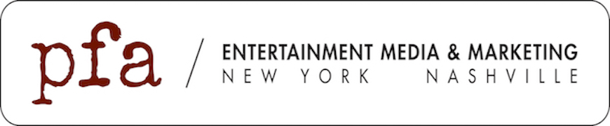

For Immediate Release
August 19, 2025
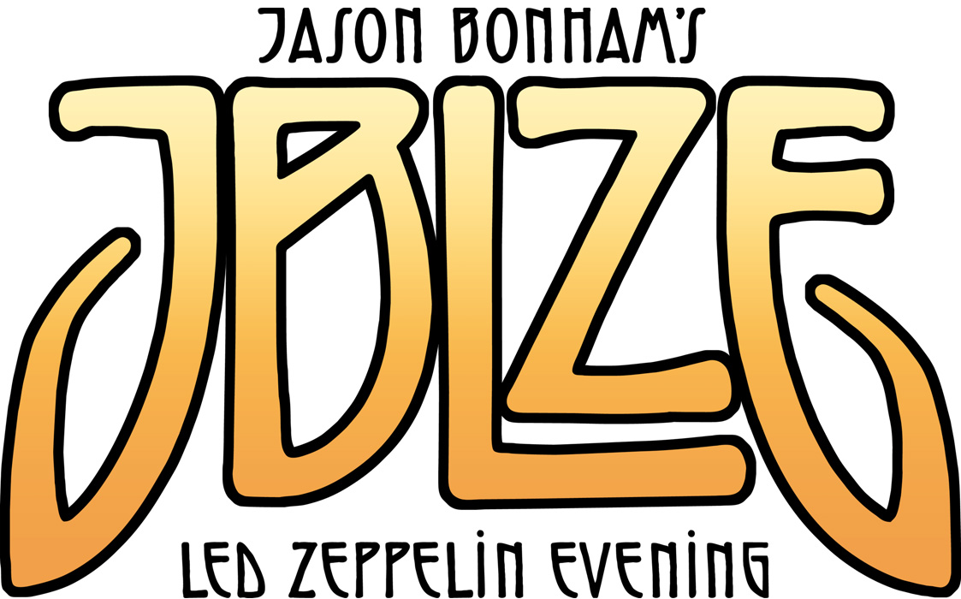
With Demand Still High for Performances,
Jason Bonham’s Led Zeppelin Evening
Announces a Third Leg Celebrating the
50th Anniversary of Physical Graffiti
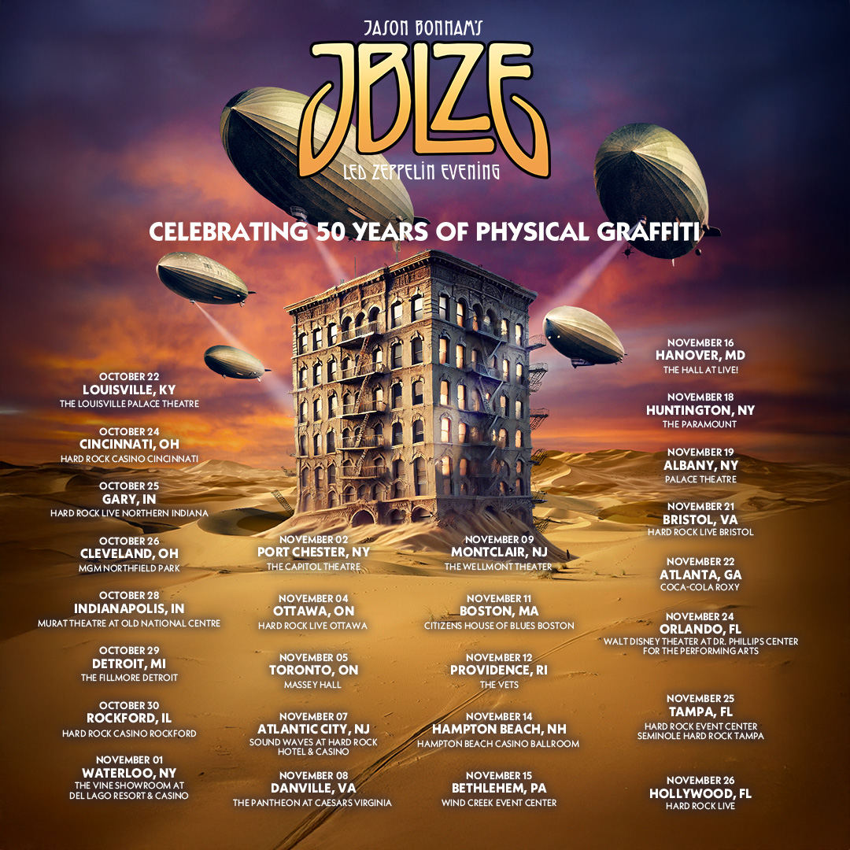
Next Round of Tour Dates to Run Throughout October and November

Public On Sale This Friday, August 22nd at 10AM Local Time

(New York, NY) – With the latest batch of tour dates playing to capacity crowds and favorable fan response,
Jason Bonham’s Led Zeppelin Evening/JBLZE is announcing one more tour to celebrate the 50th Anniversary of the Led Zeppelin classic, Physical Graffiti. This upcoming leg adds 26 more markets for fans to experience classics such as “The Wanton Song” and “Kashmir” live alongside deeper cuts like “In The Light” and “Boogie With Stu.” Along with playing the iconic album in its entirety, other Led Zeppelin favorites including “Good Times Bad Times,” “Whole Lotta Love” and of course “Stairway To Heaven” find their way into the setlist. The final Physical Graffiti tour kicks off on October 22 in Louisville, KY and wraps November 26 in Hollywood, FL. Along the way, the tour will make stops in Detroit, MI (October 29), Atlantic City, NJ (November 7), Huntington, NY (November 18) and Tampa, FL (November 25) to name a few markets. Public on sale for tickets will begin on Friday, August 22 and more information on all tickets and performances can be found at https://www.jasonbonham.net.

“For me, this isn’t just an album—it’s the album,” declares Jason Bonham. “Physical Graffiti has always been my ultimate Led Zeppelin record, and I set out to honor its 50th anniversary with 50 unforgettable shows. That vision now looks more like 70 shows ! The last two tours have been nothing short of electrifying, and I know the Fall tour will raise the bar even higher as we revisit some of our favorite places on the east coast . I’m counting down the days until JBLZE share our final powerful, celebration of Physical Graffiti together.”

JBLZE Fall Tour Dates

Wed, Oct 22 - Louisville, KY - The Louisville Palace Theatre
Fri, Oct 24 - Cincinnati, OH - Hard Rock Casino Cincinnati
Sat, Oct 25 - Gary, IN - Hard Rock Live Northern Indiana
Sun, Oct 26 - Cleveland, OH - MGM Northfield Park
Tue, Oct 28 - Indianapolis, IN - Murat Theatre at Old National Centre
Wed, Oct 29 - Detroit, MI - The Fillmore Detroit
Thu, Oct 30 - Rockford, IL - Hard Rock Casino Rockford
Sat, Nov 1 - Waterloo, NY - The Vine Showroom at del Lago Resort & Casino
Sun, Nov 2 - Port Chester, NY - The Capitol Theatre
Tue, Nov 4 - Ottawa, ON - Hard Rock Live Ottawa
Wed, Nov 5 - Toronto, ON - Massey Hall
Fri, Nov 7 - Atlantic City, NJ - Sound Waves at Hard Rock Hotel & Casino
Sat, Nov 8 - Danville, VA - The Pantheon at Caesars Virginia
Sun, Nov 9 - Montclair, NJ - The Wellmont Theater
Tue, Nov 11 - Boston, MA - Citizens House of Blues Boston
Wed, Nov 12 - Providence, RI - The VETS
Fri, Nov 14 - Hampton Beach, NH - Hampton Beach Casino Ballroom
Sat, Nov 15 - Bethlehem, PA - Wind Creek Event Center
Sun, Nov 16 - Hanover, MD - The HALL at Live!
Tue, Nov 18 - Huntington, NY - The Paramount
Wed, Nov 19 - Albany, NY - Palace Theatre
Fri, Nov 21 - Bristol, VA Hard Rock Live Bristol
Sat, Nov 22 - Atlanta, GA - Coca-Cola Roxy
Mon, Nov 24 - Orlando, FL - Walt Disney Theater at Dr. Phillips Center for the Performing Arts
Tue, Nov 25 - Tampa, FL - Hard Rock Event Center – Seminole Hard Rock Tampa
Wed, Nov 26 - Hollywood, FL - Hard Rock Live

Previously Announced JBLZE Tour Dates

Tue, Aug 19 – Monterey, CA – Golden State Theatre
Thu, Aug 21 – Anaheim, CA – Grove of Anaheim
Fri, Aug 22 – Alpine, CA – Viejas Casino & Resort
Sat, Aug 23 – Bakersfield, CA – Dignity Health Theater
Mon, Aug 25 – Salem, OR – Oregon State Fair
Tue, Aug 26 – Jacksonville, OR – Britt Music & Arts Festival
Wed, Aug 27 – Boise, ID – Morrison Center for the Performing Arts
Fri, Aug 29 – Spokane, WA – Martin Woldson Theater at The Fox
Sat, Aug 30 – Seattle, WA – Paramount Theatre
Sun, Aug 31 – Vancouver, BC – Orpheum Theatre

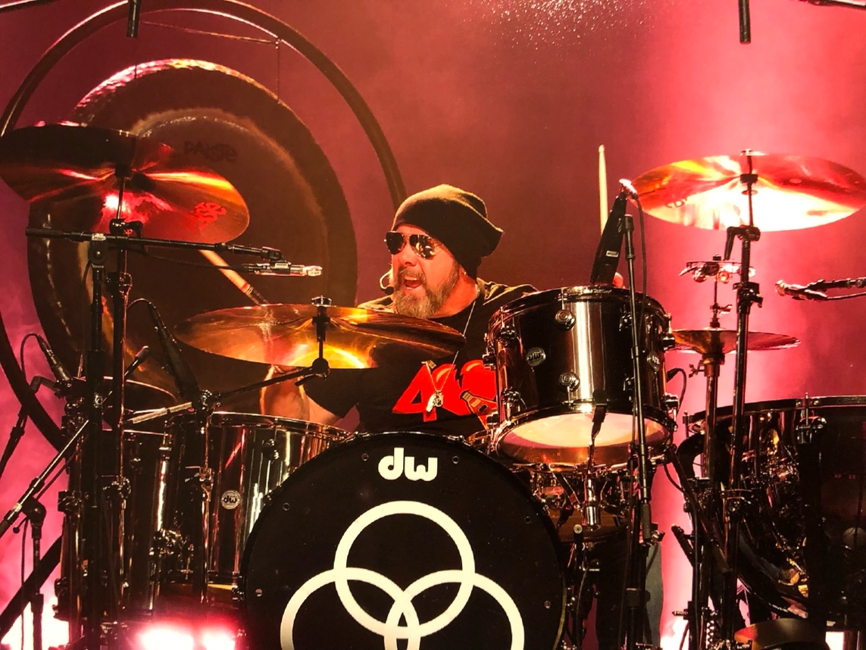
(Photo Credit: Frank Melfi)

About Jason Bonham
Jason Bonham always finds himself at home behind the drumkit. From this spot, he has anchored the tempo for a myriad of the most legendary artists of all-time. It’s the place where he initially realized his destiny as a kid. It’s a tried-and-true safe harbor for the expression of his purest emotions. It’s a direct conduit to his late father and Led Zeppelin drummer John Bonham. Following stints with Airrace and Virginia Wolf, he handled drums on Jimmy Page’s gold-certified Outrider. During 1988, he notably accompanied Page, John Paul Jones, and Robert Plant behind the kit for Led Zeppelin at the Atlantic Records 40th Anniversary Celebration Concert. Beyond helming solo projects such as Bonham and The Jason Bonham Band, he appeared in Rock Star with Mark Wahlberg and Jennifer Anniston. Plus, he lent his talents to Foreigner, Little Steven, Joe Bonamassa, and Paul Rodgers. He held down the drums for Led Zeppelin’s 2007 reunion at the Ahmet Ertegun Tribute Concert—which set the Guinness World Record® for “Highest Demand for Tickets for One Music Concert.” The evening spawned the Celebration Day concert film and multiplatinum album, debuting Top 10 on the Billboard 200, selling three million-plus copies, and garnering a GRAMMY®. Other notable projects have included Black Country Communion (Bonamassa, Glenn Hughes, and Derek Sherinian) and California Breed (Hughes and producer and guitarist Andrew Watt). He joined Sammy Hagar and the Circle with Van Halen’s Michael Anthony and Vic Johnson. In 2010, he introduced Jason Bonham’s Led Zeppelin Evening (JBLZE), packing venues coast-to-coast and supporting everyone from Heart to Kid Rock. A spectacle of top-flight musicianship, arresting visuals, mind-blowing lighting, and emotionally charged storytelling, Rolling Stone hailed its “set of Led Zep gems that were strikingly faithful to the originals,” while Billy Joel personally handpicked JBLZE to open a handful of dates. Ultimately, Jason remains forever at home on the drums.

Connect with Jason Bonham/JBLZE at:
Website: https://www.jasonbonham.net
Facebook: https://www.facebook.com/JasonBonhamOfficial
Instagram: https://www.instagram.com/jasonbonham/
X: https://x.com/Jason_Bonham
TikTok: https://www.tiktok.com/@jasonbonham66

For more information on Jason Bonham or JBLZE, please contact:

Kevin Chiaramonte / PFA Media / kevinc@pfamedia.net

