EMBARGOED UNTIL TUESDAY, NOVEMBER 14 @ 12PM (ET)
JUDAS PRIEST ANNOUNCES THE INVINCIBLE SHIELD TOUR

Sabaton To Join Across All Shows

Tickets Available Starting Wednesday, November 15 with Artist Presale

General Onsale Begins on Friday, November 17 at 10AM Local on judaspriestinvincibleshield.com

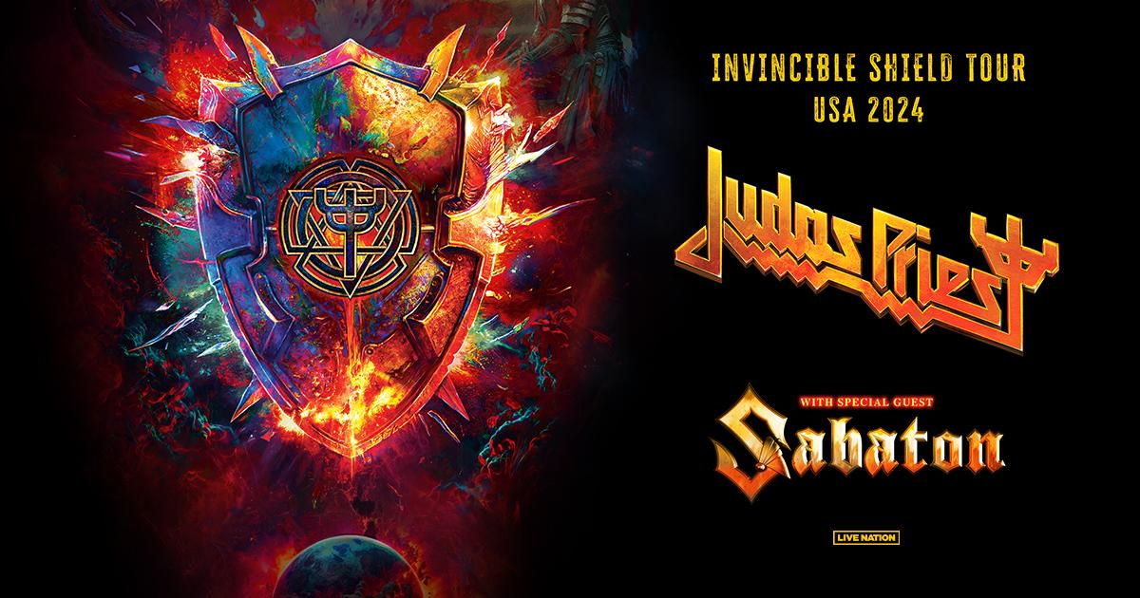
Today, heavy metal titans Judas Priest have announced their Invincible Shield Tour with special guest Sabaton. The all-time greats will take over the U.S.A. this spring with 14 shows. Produced by Live Nation, the tour kicks off on April 18 at Toyota Oakdale Theatre in Wallingford, CT making stops in Reading, PA; Boston, MA; Rosemont, IL; Washington, DC and more before wrapping up in Syracuse, NY at Empower Federal Credit Union Amphitheater at Lakeview on May 22. Full ticketing and tour dates are available below. Metalheads are in for the show of a lifetime as few rock or metal acts remain as much of a must-see live attraction as Judas Priest.

Also, on Friday 17th November JUDAS PRIEST will release ‘Trial By Fire’ the second song from their highly-anticipated new album Invincible Shield after the acclaimed lead single ‘Panic Attack’ https://judaspriest.lnk.to/InvincibleShield

TICKETS: Tickets will be available starting with an artist presale beginning on Wednesday, November 15. Additional presales will run throughout the week ahead of the general on-sale beginning on Friday, November 17 at 10am local time at judaspriestinvincibleshield.com.

JUDAS PRIEST: INVINCIBLE SHIELD TOUR DATES:
Thu Apr 18 – Wallingford, CT – Toyota Oakdale Theatre
Fri Apr 19 – Newark, NJ – Prudential Center
Sun Apr 21 – Reading, PA – Santander Arena
Wed Apr 24 – Bangor, ME – Cross Insurance Center
Thu Apr 25 – Boston, MA – MGM Music Hall at Fenway
Sat Apr 27 - Youngstown, OH - Covelli Center*
Sun Apr 28 – Indianapolis, IN – Everwise Amphitheater at White River
Wed May 01 – Rosemont, IL – Rosemont Theatre
Thu May 02 – Minneapolis, MN – The Armory
Sat May 4 - Kalamazoo, MI - Wings Event Center*
Sun May 05 – Maryland Heights, MO – St Louis Music Park
Tue May 07 - Huntsville, AL - VBC Propst Arena*
Thu May 09 - Daytona, FL - Welcome to Rockville^
Sat May 11 – Alpharetta, GA – Ameris Bank Amphitheatre
Sun May 12 - Mobile, AL - Mobile Civic Center Arena*
Tue May 14 – Charlotte, NC – PNC Music Pavilion
Fri May 17 - Evansville, IN - Ford Center*
Sun May 19 – Washington, DC –The Theater at MGM National Harbor
Tue May 21 – Albany, NY – MVP Arena
Wed May 22 – Syracuse, NY – Empower Federal Credit Union Amphitheater at Lakeview
*Not a Live Nation Date
^Festival Performance

ABOUT JUDAS PRIEST
Judas Priest, a powerhouse in the world of heavy metal has spent over 50 years crafting a legendary career. Emerging from Birmingham in 1969, their impact and influence in the genre remain unparalleled. The band originally solidified their place in music history with iconic albums like 'Sad Wings of Destiny' and 'Sin After Sin' known for metal anthems like 'Sinner' and 'Hell Bent for Leather' while pioneering the leather-and-studs image now synonymous with the metal culture

The '80s marked their pinnacle with classic albums 'British Steel', 'Screaming for Vengeance', and 'Defenders of the Faith', generating timeless hits like 'Breaking the Law'. Despite lineup changes and various challenges, the band's resilience remained unwavering. In 2018 Rob Halford, Glenn Tipton, Richie Faulkner, Ian Hill and Scott Travis released 'Firepower' which soared as one of their most successful albums, backed by an extensive global tour

Amid health setbacks and the pandemic, they persevered with a 50th-anniversary tour and a Rock and Roll Hall of Fame induction. Preparing for the release of their 19th studio album 'Invincible Shield' and a headlining performance at the 2023 PowerTrip Music Festival, Judas Priest's unwavering dedication to spreading their heavy metal legacy continues, promising to rock on into 2024 and beyond.

About Live Nation Entertainment
Live Nation Entertainment (NYSE: LYV) is the world’s leading live entertainment company comprised of global market leaders: Ticketmaster, Live Nation Concerts, and Live Nation Sponsorship. For additional information, visit www.livenationentertainment.com.

MEDIA CONTACTS:

Judas Priest
Chip Ruggieri | Chip@ChipsterPR.com

Live Nation Concerts
Monique Sowinski | moniquesowinski@livenation.com
Valeska Thomas | valeskathomas@livenation.com

To apply for media credentials for show coverage: livenation.com/pressrequests

